Medicall Management System

Dbconnect.php

<?php

$connect=mysql_connect("localhost","root","");

mysql_select_db("medical_manage",$connect);

?>

Index.php

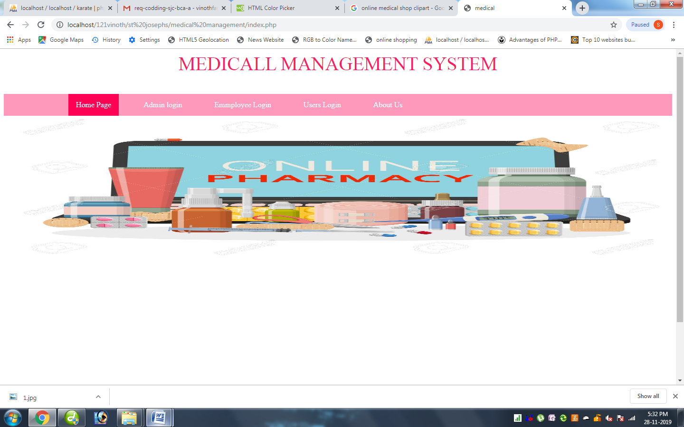

<html>

<title> medical</title>

<style>

p

{

color:#ff1a66;

text-align: center;

text-transform: uppercase;

font-size:40px;

}

ul {

list-style-type: none;

margin: 0;

padding: 0;

overflow: hidden;

background-color: #ff99bb;

position: -webkit-sticky; /* Safari */

position: sticky;

top: 0;

border-radius:0px;

}

li {

float: left;

}

li a {

display: block;

color: white;

text-align: center;

padding: 14px 16px;

text-decoration: none;

}

li a:hover {

background-color: #ff0055;

}

.active {

background-color: #ff0055;

}

#footer {

border: 2px solid #ff99bb;

padding: 45px;

background: #ff99bb;

background-repeat: no-repeat;

background-size: 1420px 100px;

border-radius:0px;

text-align:center;

text-decoration:blink;

font-family: Arial;

font-size:15px;

}

#bg1 {

padding:180px;

background:url("images/1.jpg");

background-repeat: no-repeat;

background-size: 1420px 300px;

border-radius:5px;

border-radius:0px;

font-size:35px;

}

</style>

</head>

<p>Medicall Management System</p>

<ul>

<li><a href="#">&nbsp; &nbsp; &nbsp; &nbsp; &nbsp;</a></li>

<li><a href="#">&nbsp; &nbsp; &nbsp; &nbsp; &nbsp;</a></li>

<li><a class="active" href="index.php">Home Page</a></li>

<li><a href="#">&nbsp;</a></li>

<li><a href="admin.php">Admin login</a></li>

<li><a href="#">&nbsp;</a></li>

<li><a href="emp.php">Emmployee Login</a></li>

<li><a href="#">&nbsp;</a></li>

<li><a href="user.php">Users Login</a></li>

<li><a href="#">&nbsp;</a></li>

<li><a href="about.php">About Us</a></li>

</ul>

<div id="bg1"> </div>

<div> &nbsp;</div>

<br>

<br>

<br>

<br>

<br>

<br>

<br>

<br>

<br>

<br>

<br>

<br>

<div id="footer"> Copyrights & designedby@Medical Managment</div>

Admin.php

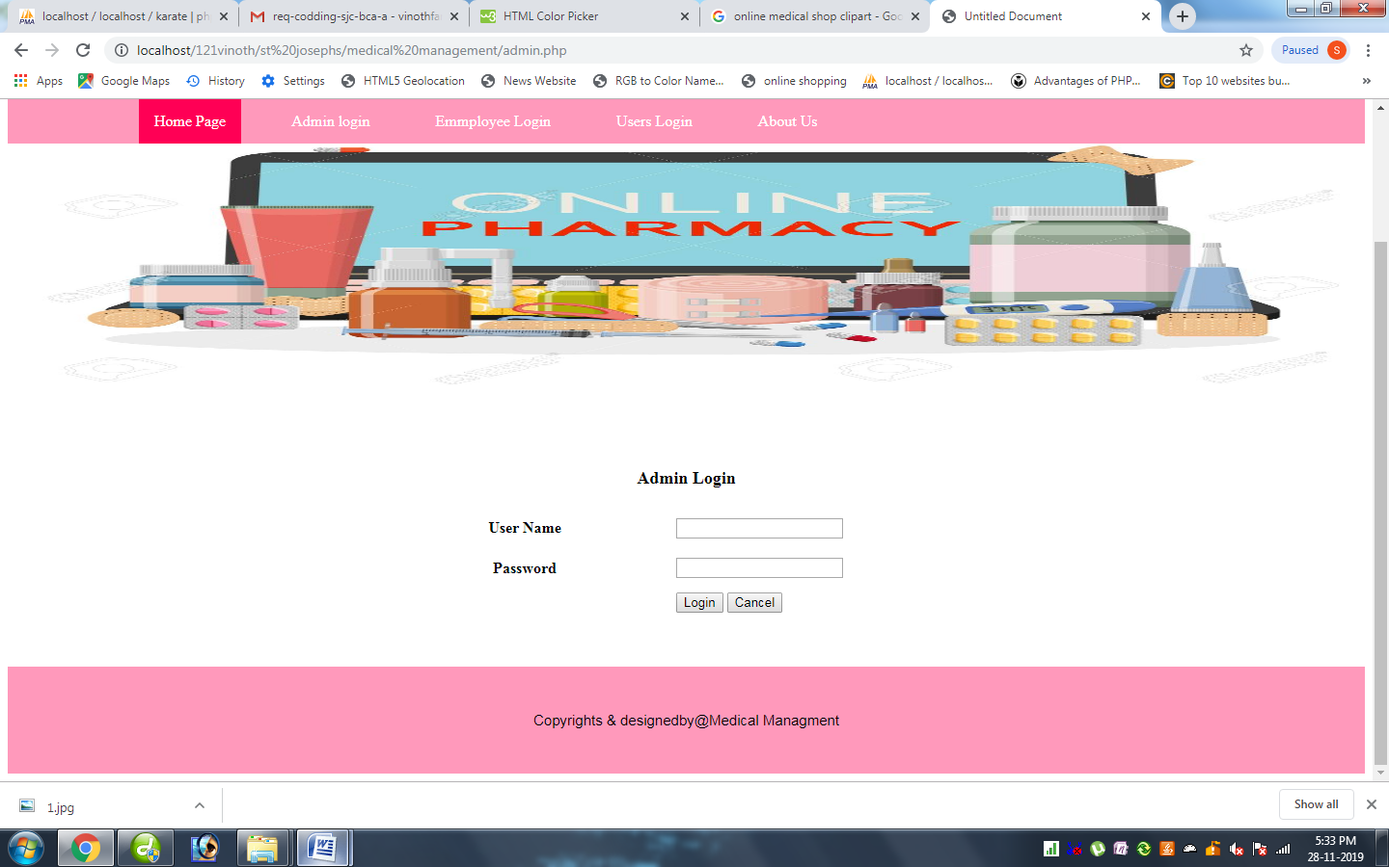

<?php

include("dbconnect.php");

extract($_POST);

session_start();

if(isset($_POST['btn']))

{

$qry=mysql_query("select * from admin where name='$uname' && psw='$password'");

$num=mysql_num_rows($qry);

if($num==1)

{

?>

<script>alert('welcome to admin home page');

</script>

<?php

header("location:adminhome.php");

}

else

{

echo "<script>alert('User Name Password Wrong.....')</script>";

}

}

?>

<html>

<title> Medical</title>

<style>

p

{

color:#ff1a66;

text-align: center;

text-transform: uppercase;

font-size:40px;

}

ul {

list-style-type: none;

margin: 0;

padding: 0;

overflow: hidden;

background-color: #ff99bb;

position: -webkit-sticky; /* Safari */

position: sticky;

top: 0;

border-radius:0px;

}

li {

float: left;

}

li a {

display: block;

color: white;

text-align: center;

padding: 14px 16px;

text-decoration: none;

}

li a:hover {

background-color: #ff0055;

}

.active {

background-color: #ff0055;

}

#footer {

border: 2px solid #ff99bb;

padding: 45px;

background: #ff99bb;

background-repeat: no-repeat;

background-size: 1420px 100px;

border-radius:0px;

text-align:center;

text-decoration:blink;

font-family: Arial;

font-size:15px;

}

#bg1 {

padding:180px;

background:url("images/1.jpg");

background-repeat: no-repeat;

background-size: 1420px 300px;

border-radius:5px;

border-radius:0px;

font-size:35px;

}

</style>

</head>

<p>Medicall Management System</p>

<ul>

<li><a href="#">&nbsp; &nbsp; &nbsp; &nbsp; &nbsp;</a></li>

<li><a href="#">&nbsp; &nbsp; &nbsp; &nbsp; &nbsp;</a></li>

<li><a class="active" href="index.php">Home Page</a></li>

<li><a href="#">&nbsp;</a></li>

<li><a href="admin.php">Admin login</a></li>

<li><a href="#">&nbsp;</a></li>

<li><a href="emp.php">Emmployee Login</a></li>

<li><a href="#">&nbsp;</a></li>

<li><a href="user.php">Users Login</a></li>

<li><a href="#">&nbsp;</a></li>

<li><a href="about.php">About Us</a></li>

</ul>

<div id="bg1"> </div>

<div> &nbsp;</div>

<form id="form1" name="form1" method="post" action="">

<table width="46%" border="0" align="center">

<tr>

<td colspan="2" rowspan="1"><div align="center" class="style1"><strong><font size="+1">Admin Login</font> </div></td>

</tr>

<tr>

<td width="48%">&nbsp;</td>

<td width="52%">&nbsp;</td>

</tr>

</tr>

<tr>

<td height="31"align="center"><span class="style2"><strong>User Name </strong></span></td>

<td><label>

<input name="uname" type="text" id="uname" />

</label></td>

</tr>

<tr>

<td height="44" align="center"><span class="style2"><strong>Password</strong></span></td>

<td><label>

<input name="password" type="password" id="password" />

</label></td>

</tr>

<tr>

<td>&nbsp;</td>

<td rowspan="2"><label>

<input name="btn" type="submit" id="btn" value="Login" />

<input type="reset" name="Submit2" value="Cancel" />

</label></td>

</tr>

</table>

</form>

<br />

<br />

<br>

<div id="footer"> Copyrights & designedby@Medical Managment</div>

Emp.php

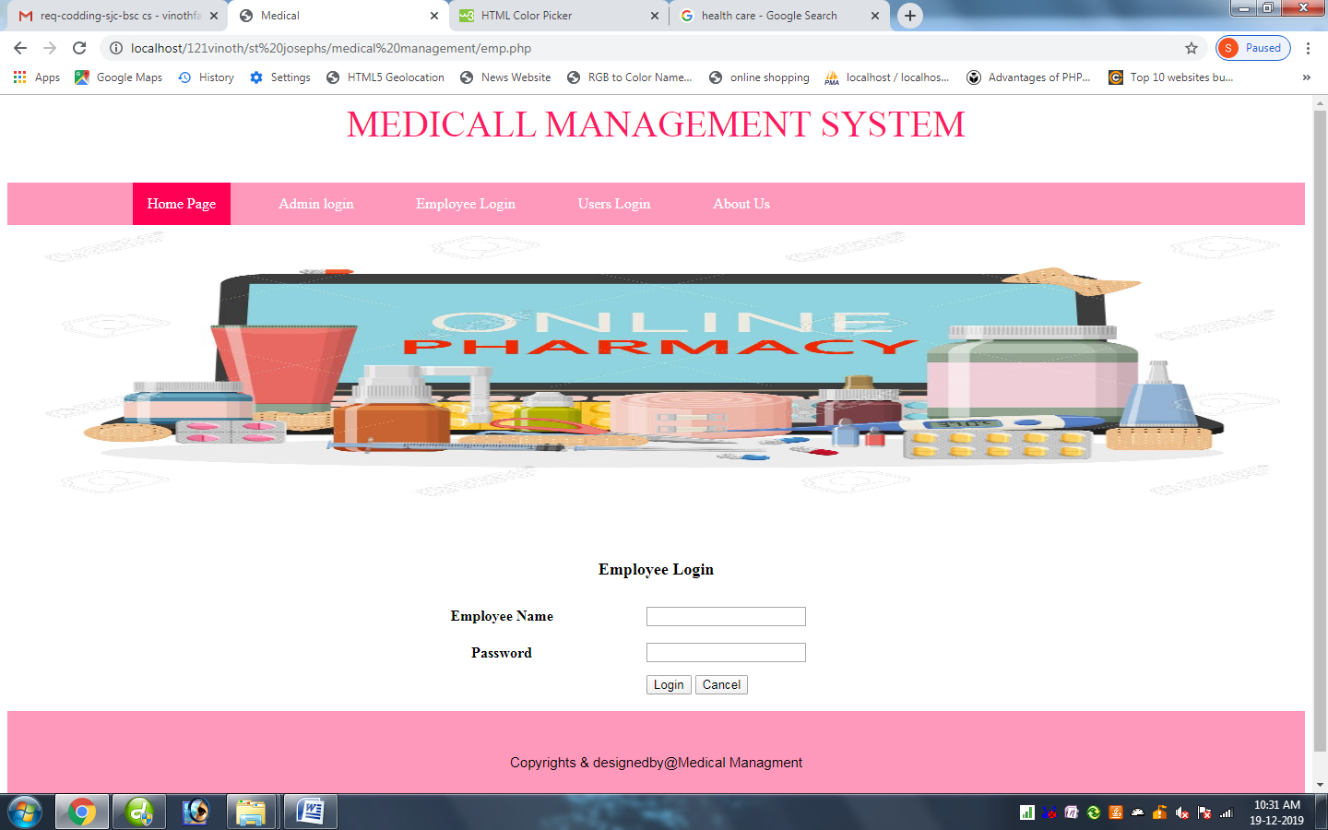



<?php

include("dbconnect.php");

extract($_POST);

session_start();

if(isset($_POST['btn']))

{

$qry=mysql_query("select * from emp where name='$uname' && psw='$password'");

$num=mysql_num_rows($qry);

if($num==1)

{

?>

<script>alert('welcome to employee home page');

</script>

<?php

header("location:emphome.php");

}

else

{

echo "<script>alert('User Name Password Wrong.....')</script>";

}

}

?>

<html>

<title> Medical</title>

<style>

p

{

color:#ff1a66;

text-align: center;

text-transform: uppercase;

font-size:40px;

}

ul {

list-style-type: none;

margin: 0;

padding: 0;

overflow: hidden;

background-color: #ff99bb;

position: -webkit-sticky; /* Safari */

position: sticky;

top: 0;

border-radius:0px;

}

li {

float: left;

}

li a {

display: block;

color: white;

text-align: center;

padding: 14px 16px;

text-decoration: none;

}

li a:hover {

background-color: #ff0055;

}

.active {

background-color: #ff0055;

}

#footer {

border: 2px solid #ff99bb;

padding: 45px;

background: #ff99bb;

background-repeat: no-repeat;

background-size: 1420px 100px;

border-radius:0px;

text-align:center;

text-decoration:blink;

font-family: Arial;

font-size:15px;

}

#bg1 {

padding:180px;

background:url("images/1.jpg");

background-repeat: no-repeat;

background-size: 1420px 300px;

border-radius:5px;

border-radius:0px;

font-size:35px;

}

</style>

</head>

<p>Medicall Management System</p>

<ul>

<li><a href="#">&nbsp; &nbsp; &nbsp; &nbsp; &nbsp;</a></li>

<li><a href="#">&nbsp; &nbsp; &nbsp; &nbsp; &nbsp;</a></li>

<li><a class="active" href="index.php">Home Page</a></li>

<li><a href="#">&nbsp;</a></li>

<li><a href="admin.php">Admin login</a></li>

<li><a href="#">&nbsp;</a></li>

<li><a href="emp.php">Employee Login</a></li>

<li><a href="#">&nbsp;</a></li>

<li><a href="user.php">Users Login</a></li>

<li><a href="#">&nbsp;</a></li>

<li><a href="about.php">About Us</a></li>

</ul>

<div id="bg1"> </div>

<form id="form1" name="form1" method="post" action="">

<table width="46%" border="0" align="center">

<tr>

<td colspan="2" rowspan="1"><div align="center" class="style1"><strong><font size="+1">Employee Login</font> </div></td>

</tr>

<tr>

<td width="48%">&nbsp;</td>

<td width="52%">&nbsp;</td>

</tr>

</tr>

<tr>

<td height="31"align="center"><span class="style2"><strong>Employee Name </strong></span></td>

<td><label>

<input name="uname" type="text" id="uname" />

</label></td>

</tr>

<tr>

<td height="44" align="center"><span class="style2"><strong>Password</strong></span></td>

<td><label>

<input name="password" type="password" id="password" />

</label></td>

</tr>

<tr>

<td>&nbsp;</td>

<td rowspan="2"><label>

<input name="btn" type="submit" id="btn" value="Login" />

<input type="reset" name="Submit2" value="Cancel" />

</label></td>

</tr>

</table>

</form>

<div id="footer"> Copyrights & designedby@Medical Managment</div>

User.php

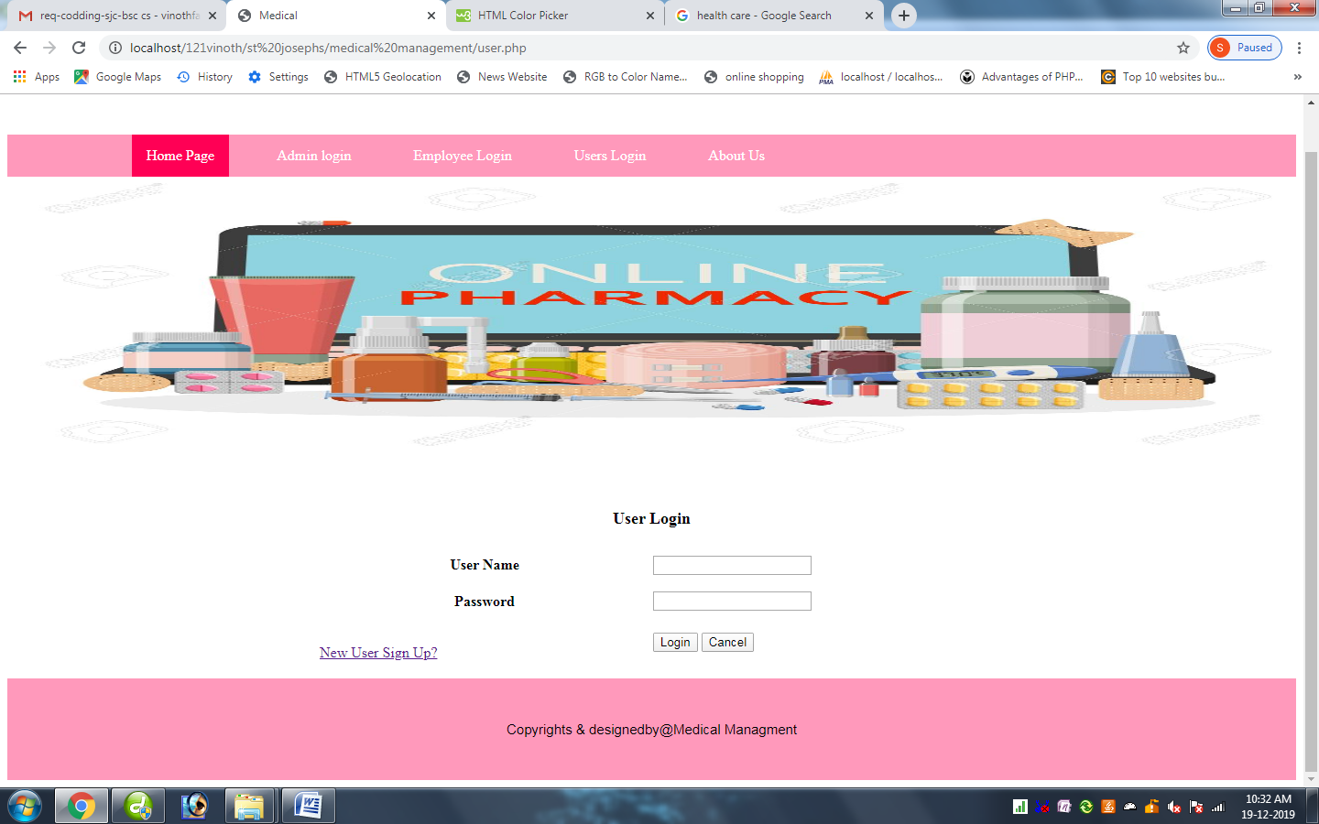

<?php

include("dbconnect.php");

extract($_POST);

session_start();

if(isset($_POST['btn']))

{

$qry=mysql_query("select * from register where uname='$uname' && psw='$password'");

$num=mysql_num_rows($qry);

if($num==1)

{

$qry=mysql_query("select * from register where uname='$uname' && psw='$password'");

$row=mysql_fetch_assoc($qry);

$_SESSION['id']=$row['id'];

?>

<script>alert('welcome to User home page');

</script>

<?php

header("location:userhome.php");

}

else

{

echo "<script>alert('User Name Password Wrong.....')</script>";

}

}

?>

<html>

<title> Medical</title>

<style>

p

{

color:#ff1a66;

text-align: center;

text-transform: uppercase;

font-size:40px;

}

ul {

list-style-type: none;

margin: 0;

padding: 0;

overflow: hidden;

background-color: #ff99bb;

position: -webkit-sticky; /* Safari */

position: sticky;

top: 0;

border-radius:0px;

}

li {

float: left;

}

li a {

display: block;

color: white;

text-align: center;

padding: 14px 16px;

text-decoration: none;

}

li a:hover {

background-color: #ff0055;

}

.active {

background-color: #ff0055;

}

#footer {

border: 2px solid #ff99bb;

padding: 45px;

background: #ff99bb;

background-repeat: no-repeat;

background-size: 1420px 100px;

border-radius:0px;

text-align:center;

text-decoration:blink;

font-family: Arial;

font-size:15px;

}

#bg1 {

padding:180px;

background:url("images/1.jpg");

background-repeat: no-repeat;

background-size: 1420px 300px;

border-radius:5px;

border-radius:0px;

font-size:35px;

}

</style>

</head>

<p>Medicall Management System</p>

<ul>

<li><a href="#">&nbsp; &nbsp; &nbsp; &nbsp; &nbsp;</a></li>

<li><a href="#">&nbsp; &nbsp; &nbsp; &nbsp; &nbsp;</a></li>

<li><a class="active" href="index.php">Home Page</a></li>

<li><a href="#">&nbsp;</a></li>

<li><a href="admin.php">Admin login</a></li>

<li><a href="#">&nbsp;</a></li>

<li><a href="emp.php">Employee Login</a></li>

<li><a href="#">&nbsp;</a></li>

<li><a href="user.php">Users Login</a></li>

<li><a href="#">&nbsp;</a></li>

<li><a href="about.php">About Us</a></li>

</ul>

<div id="bg1"> </div>

<form id="form1" name="form1" method="post" action="">

<table width="52%" border="0" align="center">

<tr>

<td colspan="2" rowspan="1"><div align="center" class="style1"><strong><font size="+1">User Login</font> </div></td>

</tr>

<tr>

<td width="36%">&nbsp;</td>

<td width="36%">&nbsp;</td>

</tr>

</tr>

<tr>

<td height="31"align="center"><span class="style2"><strong>User Name </strong></span></td>

<td><label>

<input name="uname" type="text" id="uname" />

</label></td>

</tr>

<tr>

<td height="44" align="center"><span class="style2"><strong>Password</strong></span></td>

<td><label>

<input name="password" type="password" id="password" />

</label></td>

</tr>

<tr>

<td>&nbsp;</td>

<td rowspan="2"><label>

<input name="btn" type="submit" id="btn" value="Login" />

<input type="reset" name="Submit2" value="Cancel" />

</label></td>

</tr>

<tr>

<td width="28%"><a href="register.php">New User Sign Up?</a> </td>

</tr>

</table>

</form>

<div id="footer"> Copyrights & designedby@Medical Managment</div>

Register.php

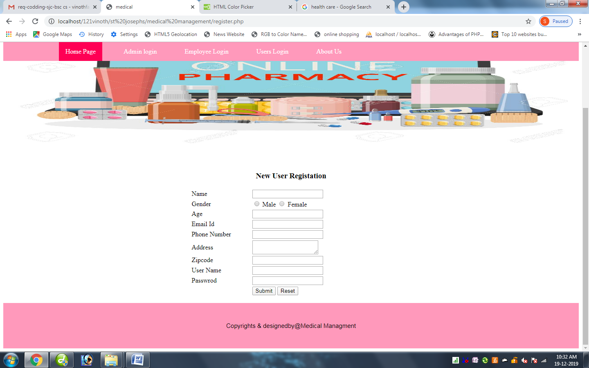

<?php

include("dbconnect.php");

extract($_POST);

session_start();

if(isset($_POST['btn']))

{

$qry=mysql_query("insert into register(name,gender,age,email,phone,address,zip,uname,psw) values('$name','$gender','$age','$email','$phone','$address','$zip','$uname','$psw')");

if($qry)

{

echo "<script>alert('inserted sucessfully')</script>";

}

else

{

echo "failed";

}

}

?>

<html>

<title> medical</title>

<style>

p

{

color:#ff1a66;

text-align: center;

text-transform: uppercase;

font-size:40px;

}

ul {

list-style-type: none;

margin: 0;

padding: 0;

overflow: hidden;

background-color: #ff99bb;

position: -webkit-sticky; /* Safari */

position: sticky;

top: 0;

border-radius:0px;

}

li {

float: left;

}

li a {

display: block;

color: white;

text-align: center;

padding: 14px 16px;

text-decoration: none;

}

li a:hover {

background-color: #ff0055;

}

.active {

background-color: #ff0055;

}

#footer {

border: 2px solid #ff99bb;

padding: 45px;

background: #ff99bb;

background-repeat: no-repeat;

background-size: 1420px 100px;

border-radius:0px;

text-align:center;

text-decoration:blink;

font-family: Arial;

font-size:15px;

}

#bg1 {

padding:180px;

background:url("images/1.jpg");

background-repeat: no-repeat;

background-size: 1420px 300px;

border-radius:5px;

border-radius:0px;

font-size:35px;

}

</style>

</head>

<p>Medicall Management System</p>

<ul>

<li><a href="#">&nbsp; &nbsp; &nbsp; &nbsp; &nbsp;</a></li>

<li><a href="#">&nbsp; &nbsp; &nbsp; &nbsp; &nbsp;</a></li>

<li><a class="active" href="index.php">Home Page</a></li>

<li><a href="#">&nbsp;</a></li>

<li><a href="admin.php">Admin login</a></li>

<li><a href="#">&nbsp;</a></li>

<li><a href="emp.php">Employee Login</a></li>

<li><a href="#">&nbsp;</a></li>

<li><a href="user.php">Users Login</a></li>

<li><a href="#">&nbsp;</a></li>

<li><a href="about.php">About Us</a></li>

</ul>

<div id="bg1"> </div>

<form id="f1" name="f1" method="post" action="#">

<table width="35%" border="0" align="center">

<tr>

<td colspan="2" align="center" ><div class="style5"><h3>New User Registation</h></div></td>

</tr>

<tr>

<td width="30%">Name</td>

<td width="70%"><input name="name" type="text" id="name" onChange="return name ()"/>

</td>

</tr>

<tr>

<td>Gender</td>

<td><input name="gender" type="radio" value="male" />

Male

<input name="gender" type="radio" value="female" />

Female</td>

</tr>

<tr>

<td>Age</td>

<td>

<input name="age" type="text" id="age" onChange="return age ()" />

</td>

</tr>

<tr>

<td>Email Id</td>

<td><input name="email" type="text" id="email" onChange="return email()" /></td>

</tr>

<tr>

<td>Phone Number </span></td>

<td><input name="phone" type="text" id="phone" onChange="return phone()" /></td>

</tr>

<tr>

<td>Address</td>

<td><textarea name="address" id="address"></textarea></td>

</tr>

<tr>

<td>Zipcode</td>

<td><input type="text" name="zip" id="zip"></td>

</tr>

<tr>

<td>User Name</td>

<td><input name="uname" type="text" id="uname" /></td>

</tr>

<tr>

<td>Passwrod</td>

<td><input name="psw" type="password" id="psw" /></td>

</tr>

<tr>

<td>&nbsp;</td>

<td><input name="btn" type="submit" id="btn" value="Submit" />

<input type="reset" name="Submit2" value="Reset" /></td>

</tr>

</table>

</form>

<div id="footer"> Copyrights & designedby@Medical Managment</div>

Userhome.php

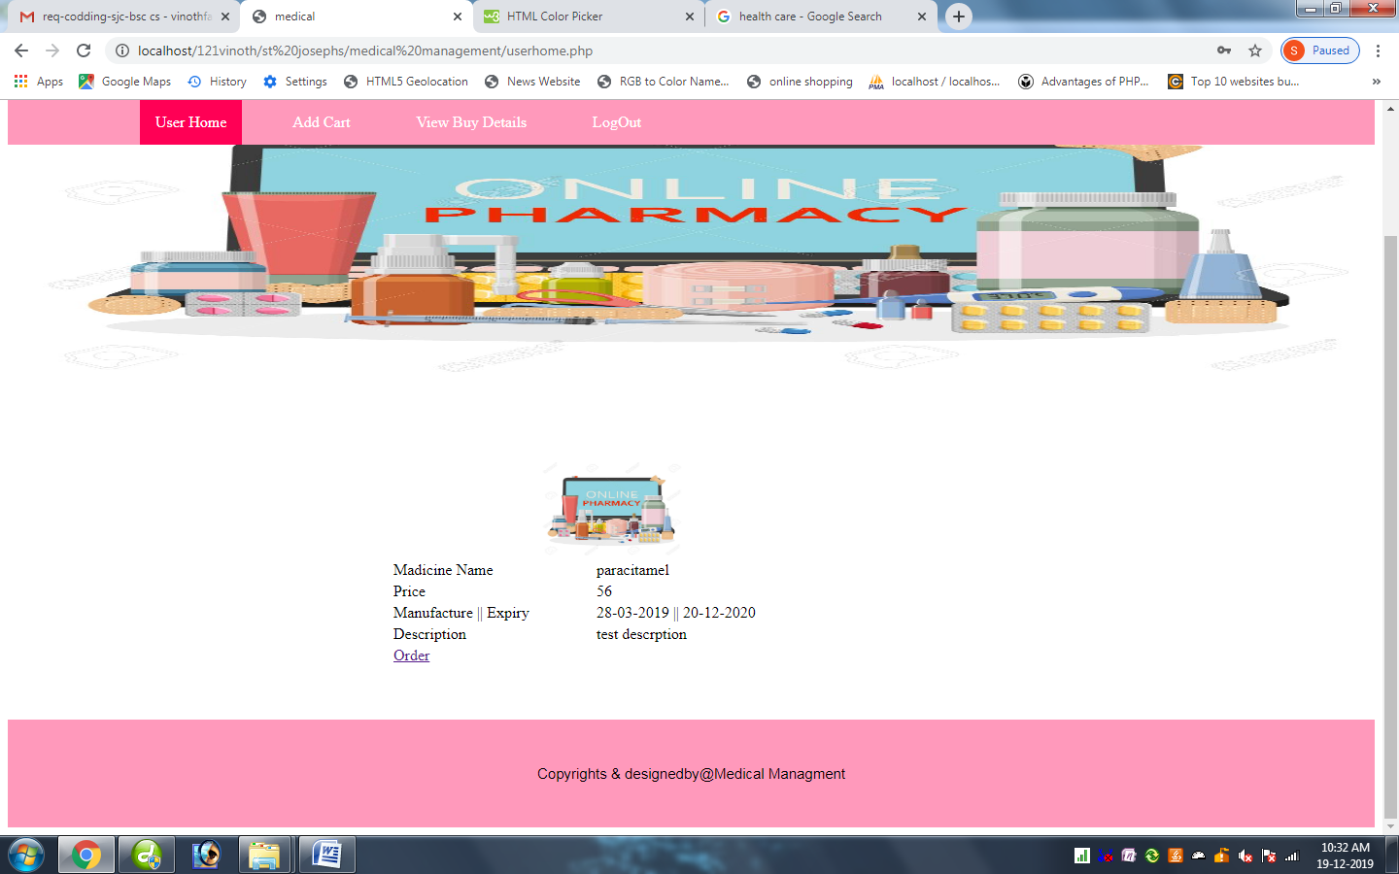

<?php

session_start();

include("dbconnect.php");

extract($_POST);

$uid=$_SESSION['id'];

if($_REQUEST['act']=="add")

{

$mid=$_REQUEST['id'];

$amnt=$_REQUEST['price'];

$mq=mysql_query("select max(id) from addcart");

$mr=mysql_fetch_array($mq);

$id=$mr['max(id)']+1;

$ins=mysql_query("insert into addcart(id,uid,orderid,bid,price,quantity,amount,status)

values($id,'$uid','0','$mid','0','0','0','0')");

header("location:userhome.php");

}

?>

<html>

<title> medical</title>

<style>

p

{

color:#ff1a66;

text-align: center;

text-transform: uppercase;

font-size:40px;

}

ul {

list-style-type: none;

margin: 0;

padding: 0;

overflow: hidden;

background-color: #ff99bb;

position: -webkit-sticky; /* Safari */

position: sticky;

top: 0;

border-radius:0px;

}

li {

float: left;

}

li a {

display: block;

color: white;

text-align: center;

padding: 14px 16px;

text-decoration: none;

}

li a:hover {

background-color: #ff0055;

}

.active {

background-color: #ff0055;

}

#footer {

border: 2px solid #ff99bb;

padding: 45px;

background: #ff99bb;

background-repeat: no-repeat;

background-size: 1420px 100px;

border-radius:0px;

text-align:center;

text-decoration:blink;

font-family: Arial;

font-size:15px;

}

#bg1 {

padding:180px;

background:url("images/1.jpg");

background-repeat: no-repeat;

background-size: 1420px 300px;

border-radius:5px;

border-radius:0px;

font-size:35px;

}

</style>

</head>

<p>Medicall Management System</p>

<ul>

<li><a href="#">&nbsp; &nbsp; &nbsp; &nbsp; &nbsp;</a></li>

<li><a href="#">&nbsp; &nbsp; &nbsp; &nbsp; &nbsp;</a></li>

<li><a class="active" href="userhome.php">User Home</a></li>

<li><a href="#">&nbsp;</a></li>

<li><a href="addcart.php">Add Cart</a></li>

<li><a href="#">&nbsp;</a></li>

<li><a href="view.php">View Buy Details</a></li>

<li><a href="#">&nbsp;</a></li>

<li><a href="index.php">LogOut</a></li>

</ul>

<div id="bg1"> </div>

<table width="44%" align="center" >

<tr>

<td width="34%">&nbsp;</td>

<td width="40%">&nbsp;</td>

<td width="21%">&nbsp;</td>

<td width="4%">&nbsp;</td>

<td width="1%">&nbsp;</td>

</tr>

<?php

$qry=mysql_query("select * from product");

while($row=mysql_fetch_array($qry))

{

?>

<tr>

<td colspan="2" align="center"><img src="images\<?php echo $row['img'];?>"width="150" height="100"></td>

</tr>

<tr>

<td>Madicine Name</td>

<td><?php echo $row['name'];?></td>

</tr>

<tr>

<td>Price</td>

<td><?php echo $row['price'];?></td>

</tr>

<tr>

<td>Manufacture || Expiry</td>

<td><?php echo $row['mfd'];?> || <?php echo $row['exd'];?></td>

</tr>

<tr>

<td>Description</td>

<td><?php echo $row['desc'];?></td>

</tr>

<tr>

<td colspan="2"><a href="userhome.php?act=add&id=<?php echo $row['id'];?>&price=<?php echo $row['price'];?>">Order</a></td>

</tr>

<?php

}

?>

</table>

<br>

<br>

<br>

<div id="footer"> Copyrights & designedby@Medical Managment</div>

Adddcart.php

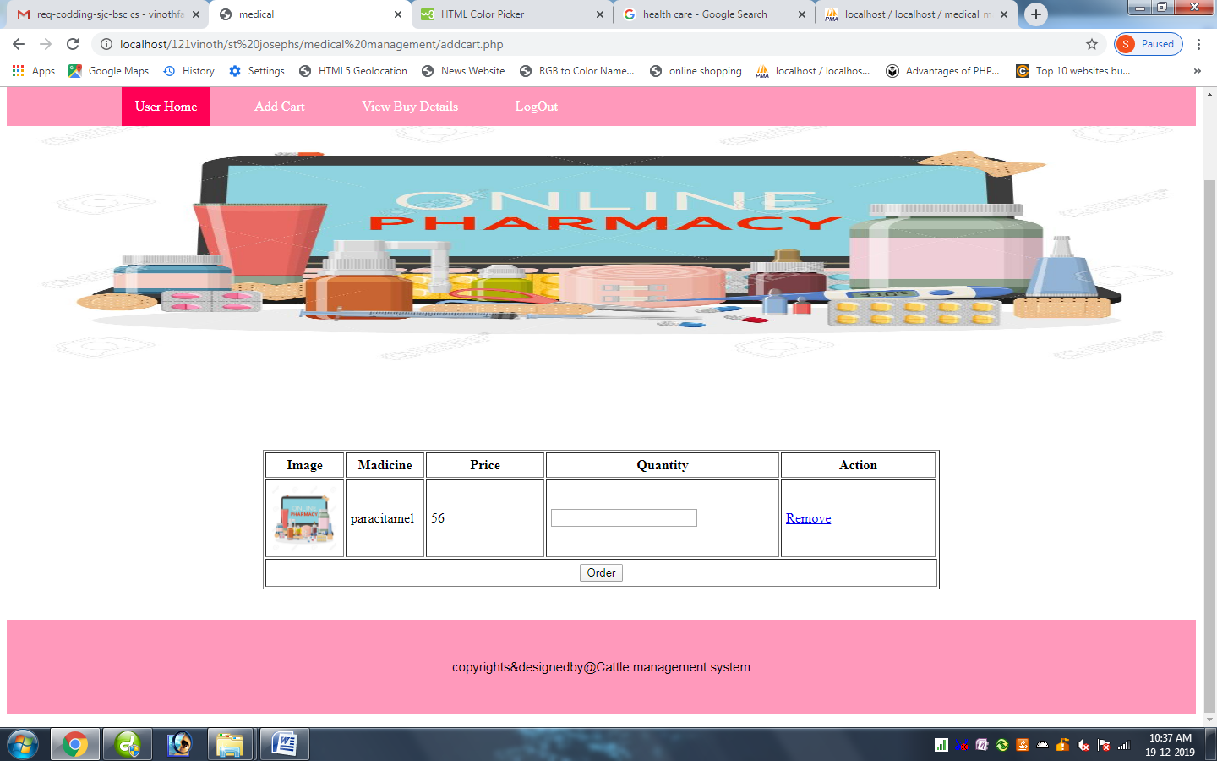

<?php

include("dbconnect.php");

session_start();

extract($_POST);

$uid=$_SESSION['id'];

if(isset($btn))

{

$amount=0;

$mq2=mysql_query("select max(orderid) from addcart");

$mr2=mysql_fetch_array($mq2);

$order=$mr2['max(orderid)']+1;

for($i=0;$i<count($gid);$i++)

{

$amt=$price[$i]*$qty[$i];

$amount+=$amt;

mysql_query("update addcart set price=$price[$i],quantity=$qty[$i],amount=$amt,status=1,orderid=$order where id=$gid[$i]");

}

header("location:payment.php?id=".$order);

}

if($_REQUEST['act']=="del")

{

$did=$_REQUEST['did'];

mysql_query("delete from addcart where id=$did");

//header("location:cart.php");

}

?>

<html>

<title> medical</title>

<style>

p

{

color:#ff1a66;

text-align: center;

text-transform: uppercase;

font-size:40px;

}

ul {

list-style-type: none;

margin: 0;

padding: 0;

overflow: hidden;

background-color: #ff99bb;

position: -webkit-sticky; /* Safari */

position: sticky;

top: 0;

border-radius:0px;

}

li {

float: left;

}

li a {

display: block;

color: white;

text-align: center;

padding: 14px 16px;

text-decoration: none;

}

li a:hover {

background-color: #ff0055;

}

.active {

background-color: #ff0055;

}

#footer {

border: 2px solid #ff99bb;

padding: 45px;

background: #ff99bb;

background-repeat: no-repeat;

background-size: 1420px 100px;

border-radius:0px;

text-align:center;

text-decoration:blink;

font-family: Arial;

font-size:15px;

}

#bg1 {

padding:180px;

background:url("images/1.jpg");

background-repeat: no-repeat;

background-size: 1420px 300px;

border-radius:5px;

border-radius:0px;

font-size:35px;

}

</style>

</head>

<p>Medicall Management System</p>

<ul>

<li><a href="#">&nbsp; &nbsp; &nbsp; &nbsp; &nbsp;</a></li>

<li><a href="#">&nbsp; &nbsp; &nbsp; &nbsp; &nbsp;</a></li>

<li><a class="active" href="userhome.php">User Home</a></li>

<li><a href="#">&nbsp;</a></li>

<li><a href="addcart.php">Add Cart</a></li>

<li><a href="#">&nbsp;</a></li>

<li><a href="view.php">View Buy Details</a></li>

<li><a href="#">&nbsp;</a></li>

<li><a href="index.php">LogOut</a></li>

</ul>

<div id="bg1"> </div>

<form name="form1" method="post" action="">

<table width="801" border="1" align="center" cellpadding="5">

<tr>

<th width="81" scope="col">Image</th>

<th width="81" scope="col">Madicine</th>

<th width="128" scope="col">Price</th>

<th width="171" scope="col">Quantity</th>

<th width="171" scope="col">Action</th>

</tr>

<?php

$q1=mysql_query("select * from addcart where uid='$uid' && status=0");

$num=mysql_num_rows($q1);

if($num>0)

{

while($r1=mysql_fetch_array($q1))

{

$q3=mysql_query("select * from product where id=".$r1['bid']."");

$r3=mysql_fetch_array($q3);

?>

<tr>

<td align="left"><img src="images/<?php echo $r3['img']; ?>" width="80" height="80" /></td>

<td align="left"><?php echo $r3['name']; ?></td>

<td align="left"><?php echo $r3['price']; ?></td>

<td align="left"><input type="text" name="qty[]" />

<input type="hidden" name="gid[]" value="<?php echo $r1['id']; ?>" />

<input type="hidden" name="bid[]" value="<?php echo $r1['bid']; ?>" />

<input type="hidden" name="price[]" value="<?php echo $r3['price']; ?>" />

</td>

<td align="left"><a href="addcart.php?act=del&did=<?php echo $r1['id'];?>">Remove</a></td>

</tr>

<?php

}

?>

<p align="center">

<tr>

<td colspan="6" align="center"><input type="submit" name="btn" value="Order" /></td>

</tr>

</p> <?php

}

else

{

echo "Order is Empty!";

}

?>

</form>

</table>

<br>

<br>

<div id="footer"> copyrights&designedby@Cattle management system</div>

Payment.php

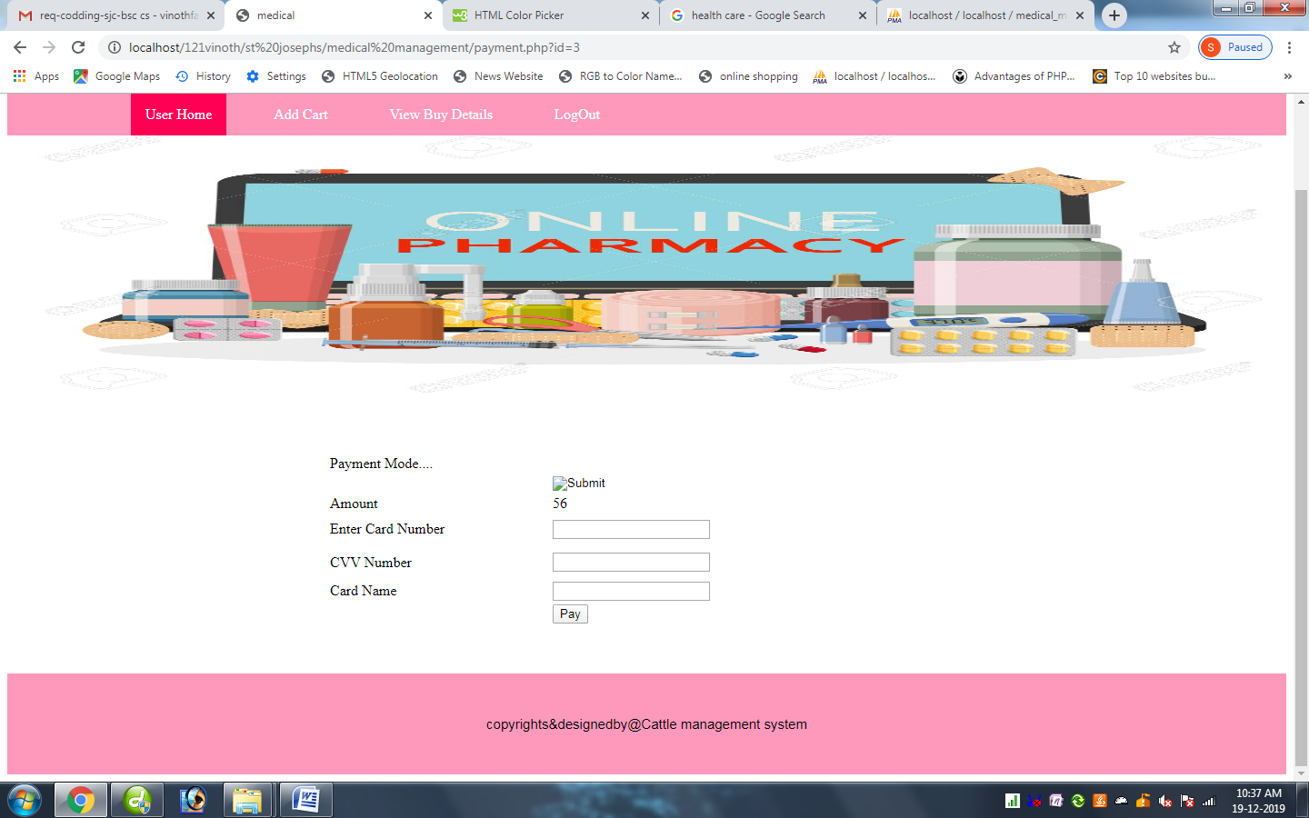

<?php

include("dbconnect.php");

session_start();

extract($_POST);

$uid=$_SESSION['id'];

$id=$_REQUEST['id'];

$sql1 = mysql_query("select sum(amount) from addcart where orderid='$id'");

$row2 = mysql_fetch_array($sql1);

$k = $row2['sum(amount)'];

if(isset($_POST['btn']))

{

?>

<script language="javascript">

alert("Amount Transfer Successfull..");

window.location.href="userhome.php";

</script>

<?php

}

?>

<html>

<title> medical</title>

<style>

p

{

color:#ff1a66;

text-align: center;

text-transform: uppercase;

font-size:40px;

}

ul {

list-style-type: none;

margin: 0;

padding: 0;

overflow: hidden;

background-color: #ff99bb;

position: -webkit-sticky; /* Safari */

position: sticky;

top: 0;

border-radius:0px;

}

li {

float: left;

}

li a {

display: block;

color: white;

text-align: center;

padding: 14px 16px;

text-decoration: none;

}

li a:hover {

background-color: #ff0055;

}

.active {

background-color: #ff0055;

}

#footer {

border: 2px solid #ff99bb;

padding: 45px;

background: #ff99bb;

background-repeat: no-repeat;

background-size: 1420px 100px;

border-radius:0px;

text-align:center;

text-decoration:blink;

font-family: Arial;

font-size:15px;

}

#bg1 {

padding:180px;

background:url("images/1.jpg");

background-repeat: no-repeat;

background-size: 1420px 300px;

border-radius:5px;

border-radius:0px;

font-size:35px;

}

</style>

</head>

<p>Medicall Management System</p>

<ul>

<li><a href="#">&nbsp; &nbsp; &nbsp; &nbsp; &nbsp;</a></li>

<li><a href="#">&nbsp; &nbsp; &nbsp; &nbsp; &nbsp;</a></li>

<li><a class="active" href="userhome.php">User Home</a></li>

<li><a href="#">&nbsp;</a></li>

<li><a href="addcart.php">Add Cart</a></li>

<li><a href="#">&nbsp;</a></li>

<li><a href="view.php">View Buy Details</a></li>

<li><a href="#">&nbsp;</a></li>

<li><a href="index.php">LogOut</a></li>

</ul>

<div id="bg1"> </div>

<form method="post" action="#">

<table width="50%" border="0" align="center">

<tr>

<td colspan="2"><span class="style1">Payment Mode.... </span></td>

</tr>

<tr>

<td>&nbsp;</td>

<td><label>

<input type="image" name="imageField" src="images/payment.png" />

</label></td>

</tr>

<tr>

<td width="35%"><span class="style4">Amount</span> </td>

<td> <?php echo $k;?></td>

</tr>

<tr>

<td height="33"><span class="style4">Enter Card Number </span></td>

<td><input name="cno" type="text" id="cno" /></td>

</tr>

<tr>

<td height="36"><span class="style4">CVV Number </span></td>

<td><input name="cvv" type="password" id="cvv" /></td>

</tr>

<tr>

<td><span class="style4">Card Name </span></td>

<td><input name="cname" type="text" id="cname" /></td>

</tr>

<tr>

<td>&nbsp;</td>

<td><input name="btn" type="submit"value="Pay" /></td>

</tr>

</table>

</form>

<br>

<br>

<div id="footer"> copyrights&designedby@Cattle management system</div>

View.php

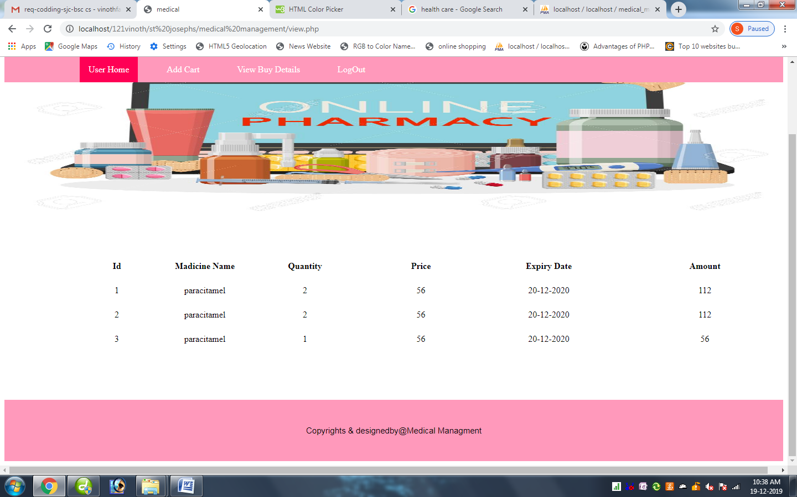

<?php

session_start();

include("dbconnect.php");

extract($_POST);

$uid=$_SESSION['id'];

?>

<html>

<title> medical</title>

<style>

p

{

color:#ff1a66;

text-align: center;

text-transform: uppercase;

font-size:40px;

}

ul {

list-style-type: none;

margin: 0;

padding: 0;

overflow: hidden;

background-color: #ff99bb;

position: -webkit-sticky; /* Safari */

position: sticky;

top: 0;

border-radius:0px;

}

li {

float: left;

}

li a {

display: block;

color: white;

text-align: center;

padding: 14px 16px;

text-decoration: none;

}

li a:hover {

background-color: #ff0055;

}

.active {

background-color: #ff0055;

}

#footer {

border: 2px solid #ff99bb;

padding: 45px;

background: #ff99bb;

background-repeat: no-repeat;

background-size: 1420px 100px;

border-radius:0px;

text-align:center;

text-decoration:blink;

font-family: Arial;

font-size:15px;

}

#bg1 {

padding:180px;

background:url("images/1.jpg");

background-repeat: no-repeat;

background-size: 1420px 300px;

border-radius:5px;

border-radius:0px;

font-size:35px;

}

</style>

</head>

<p>Medicall Management System</p>

<ul>

<li><a href="#">&nbsp; &nbsp; &nbsp; &nbsp; &nbsp;</a></li>

<li><a href="#">&nbsp; &nbsp; &nbsp; &nbsp; &nbsp;</a></li>

<li><a class="active" href="userhome.php">User Home</a></li>

<li><a href="#">&nbsp;</a></li>

<li><a href="addcart.php">Add Cart</a></li>

<li><a href="#">&nbsp;</a></li>

<li><a href="view.php">View Buy Details</a></li>

<li><a href="#">&nbsp;</a></li>

<li><a href="index.php">LogOut</a></li>

</ul>

<div id="bg1"> </div>

<table width="102%" align="center">

<tr>

<td colspan="10">&nbsp;</td>

</tr>

<tr>

<td width="9%">&nbsp;</td>

<td width="10%"><div align="center" class="style6"><strong>Id</strong> </div></td>

<td width="12%"><div align="center" class="style6"><strong>Madicine Name</strong> </div></td>

<td width="13%"><div align="center" class="style6"><strong>Quantity</strong> </div></td>

<td width="16%"><div align="center" class="style6"><strong>Price</strong> </div></td>

<td width="16%"><div align="center" class="style6"><strong>Expiry Date</strong> </div></td>

<td width="17%"><div align="center" class="style6"><strong>Amount</strong> </div></td>

</tr>

<tr>

<td colspan="10">&nbsp;</td>

</tr>

<?php

$qry=mysql_query("select * from addcart where uid='$uid'");

$i=1;

while($row=mysql_fetch_array($qry))

{

$pid=$row['bid'];

$qry1=mysql_query("select * from product where id='$pid'");

$row1=mysql_fetch_array($qry1)

?>

<tr>

<td width="9%">&nbsp;</td>

<td><div align="center"><?php echo $row['id'];?></div></td>

<td><div align="center"><?php echo $row1['name'];?></div></td>

<td><div align="center"><?php echo $row['quantity'];?></div></td>

<td><div align="center"><?php echo $row['price'];?></div></td>

<td><div align="center"><?php echo $row1['exd'];?></div></td>

<td><div align="center"><?php echo $row['amount'];?></div></td>

</tr>

<tr>

<td>&nbsp;</td>

<td>&nbsp;</td>

<td>&nbsp;</td>

<td>&nbsp;</td>

<td>&nbsp;</td>

<td>&nbsp;</td>

<td width="23%">&nbsp;</td>

</tr>

<?php

$i++;

}

?>

<tr>

<td colspan="10" align="center">&nbsp;</td>

</tr>

</table>

<br>

<br>

<br>

<div id="footer"> Copyrights & designedby@Medical Managment</div>

Adminhome.php

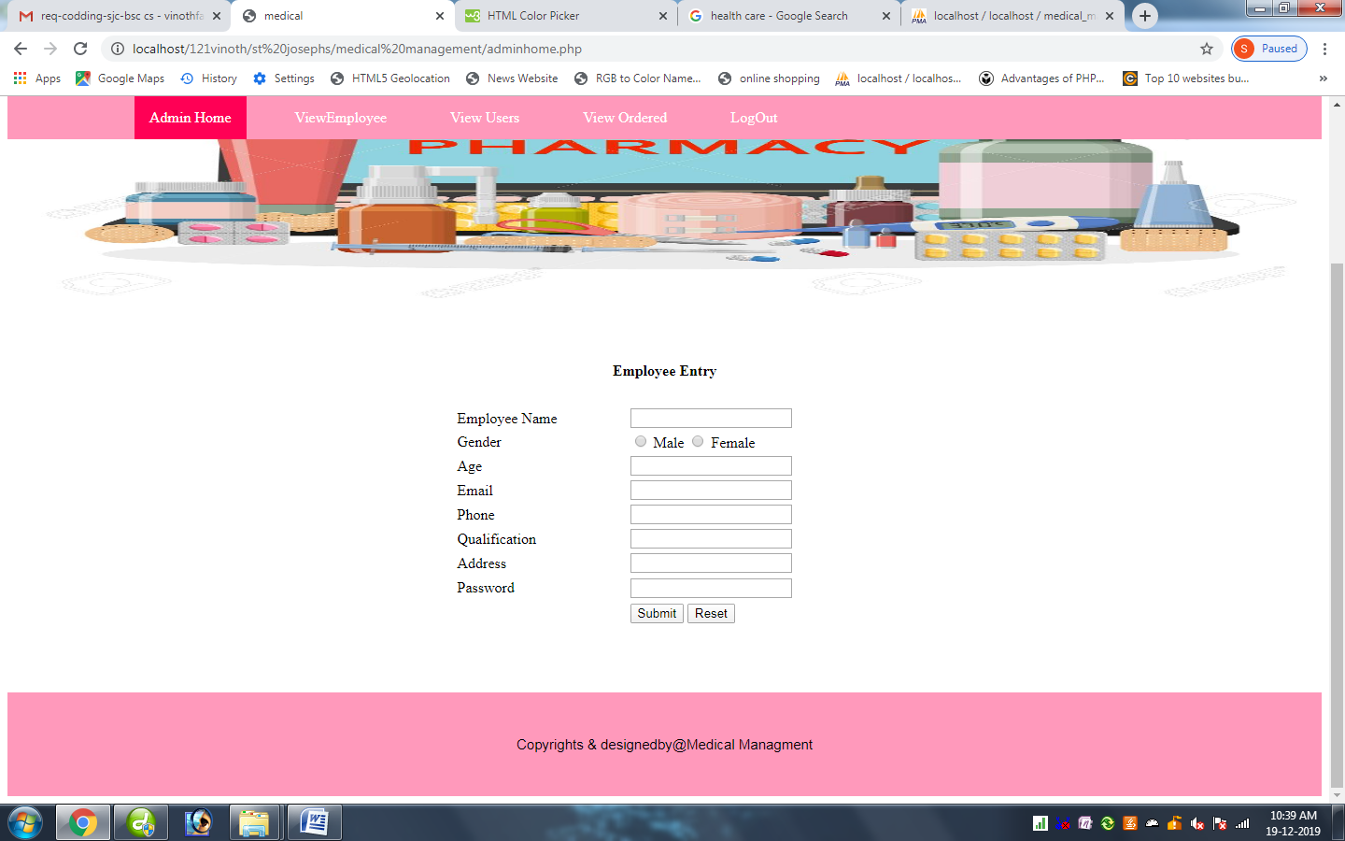

<?php

session_start();

include("dbconnect.php");

extract($_POST);

if(isset($_POST['btn']))

{

$max_qry = mysql_query("select max(id) from emp");

$max_row = mysql_fetch_array($max_qry);

$id=$max_row['max(id)']+1;

$qry=mysql_query("insert into emp values('$id','$name','$gender','$age','$email','$phone','$quali','$address','$psw')");

if($qry)

{

echo"<script> alert('Entered suceessfully')</script>";

}

else

{

echo"<script> alert('Check Fields')</script>";

}

}

?>

<html>

<title> medical</title>

<style>

p

{

color:#ff1a66;

text-align: center;

text-transform: uppercase;

font-size:40px;

}

ul {

list-style-type: none;

margin: 0;

padding: 0;

overflow: hidden;

background-color: #ff99bb;

position: -webkit-sticky; /* Safari */

position: sticky;

top: 0;

border-radius:0px;

}

li {

float: left;

}

li a {

display: block;

color: white;

text-align: center;

padding: 14px 16px;

text-decoration: none;

}

li a:hover {

background-color: #ff0055;

}

.active {

background-color: #ff0055;

}

#footer {

border: 2px solid #ff99bb;

padding: 45px;

background: #ff99bb;

background-repeat: no-repeat;

background-size: 1420px 100px;

border-radius:0px;

text-align:center;

text-decoration:blink;

font-family: Arial;

font-size:15px;

}

#bg1 {

padding:180px;

background:url("images/1.jpg");

background-repeat: no-repeat;

background-size: 1420px 300px;

border-radius:5px;

border-radius:0px;

font-size:35px;

}

</style>

</head>

<p>Medicall Management System</p>

<ul>

<li><a href="#">&nbsp; &nbsp; &nbsp; &nbsp; &nbsp;</a></li>

<li><a href="#">&nbsp; &nbsp; &nbsp; &nbsp; &nbsp;</a></li>

<li><a class="active" href="adminhome.php">Admin Home</a></li>

<li><a href="#">&nbsp;</a></li>

<li><a href="viewe.php">ViewEmployee</a></li>

<li><a href="#">&nbsp;</a></li>

<li><a href="viewu.php">View Users</a></li>

<li><a href="#">&nbsp;</a></li>

<li><a href="viewo.php">View Ordered</a></li>

<li><a href="#">&nbsp;</a></li>

<li><a href="index.php">LogOut</a></li>

</ul>

<div id="bg1">

</div>

<form id="f1" name="f1" method="post" action="#" onSubmit="return vali()">

<table width="32%" height="286" border="0" align="center">

<tr>

<td colspan="2" align="center"><strong> Employee Entry</strong></td>

</tr>

<tr>

<tr>

<td width="41%">&nbsp;</td>

<td width="59%">&nbsp;</td>

</tr>

<tr>

<td>Employee Name</td>

<td>

<input name="name" type="text">

</td>

</tr>

<tr>

<td>Gender</td>

<td>

<input name="gender" type="radio" value="male"> Male

<input name="gender" type="radio" value="female"> Female

</td>

</tr>

<tr>

<td>Age</td>

<td>

<input name="age" type="text">

</td>

</tr>

<tr>

<td>Email</td>

<td>

<input name="email" type="text">

</td>

</tr>

<tr>

<td>Phone</td>

<td>

<input name="phone" type="text">

</td>

</tr>

<tr>

<td>Qualification</td>

<td>

<input name="quali" type="text">

</td>

</tr>

<tr>

<td>Address</td>

<td>

<input name="address" type="text">

</td>

</tr>

<tr>

<td>Password</div></td>

<td>

<input name="psw" type="password"></div>

</td>

</tr>

<tr>

<td>&nbsp;</td>

<td><input name="btn" type="submit" id="btn" value="Submit" />

<input type="reset" name="Submit2" value="Reset" /></td>

</tr>

</table>

</form>

<br>

<br>

<br>

<div id="footer"> Copyrights & designedby@Medical Managment</div>

Viewe.php

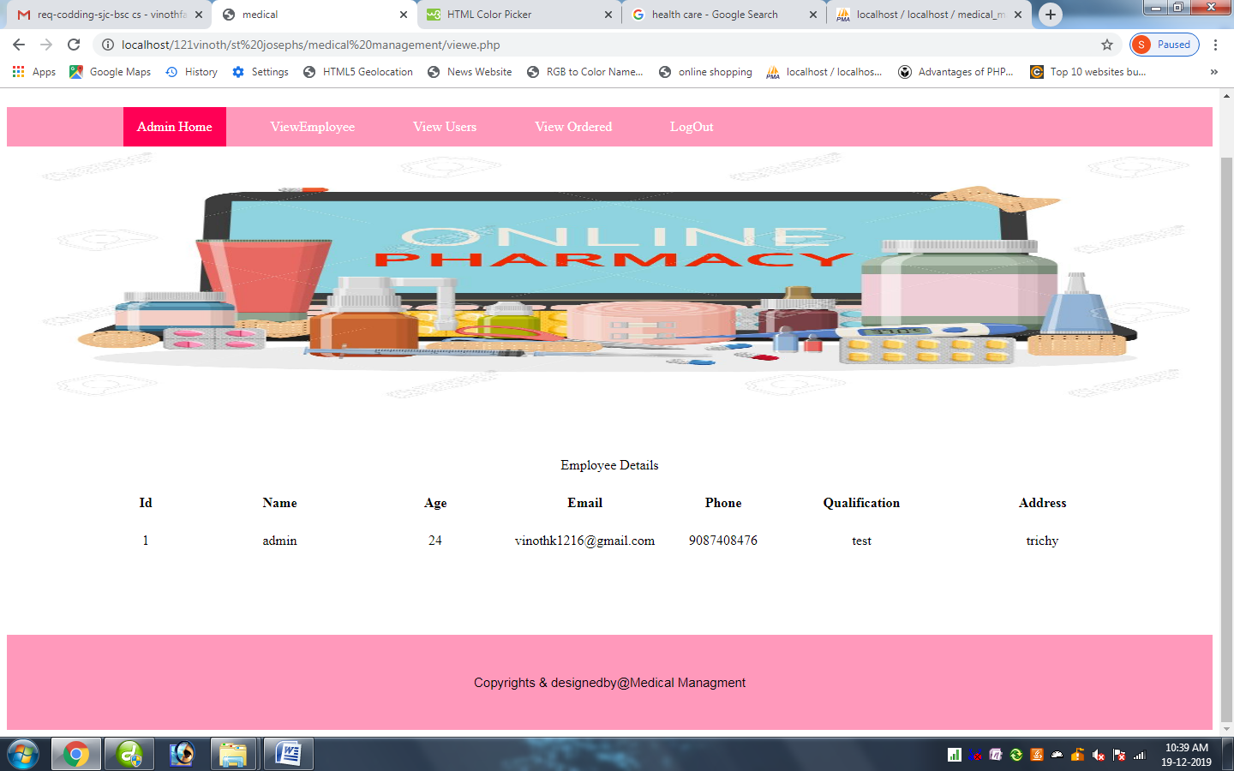

<?php

include("dbconnect.php");

session_start();

extract($_POST);

?>

<html>

<title> medical</title>

<style>

p

{

color:#ff1a66;

text-align: center;

text-transform: uppercase;

font-size:40px;

}

ul {

list-style-type: none;

margin: 0;

padding: 0;

overflow: hidden;

background-color: #ff99bb;

position: -webkit-sticky; /* Safari */

position: sticky;

top: 0;

border-radius:0px;

}

li {

float: left;

}

li a {

display: block;

color: white;

text-align: center;

padding: 14px 16px;

text-decoration: none;

}

li a:hover {

background-color: #ff0055;

}

.active {

background-color: #ff0055;

}

#footer {

border: 2px solid #ff99bb;

padding: 45px;

background: #ff99bb;

background-repeat: no-repeat;

background-size: 1420px 100px;

border-radius:0px;

text-align:center;

text-decoration:blink;

font-family: Arial;

font-size:15px;

}

#bg1 {

padding:180px;

background:url("images/1.jpg");

background-repeat: no-repeat;

background-size: 1420px 300px;

border-radius:5px;

border-radius:0px;

font-size:35px;

}

</style>

</head>

<p>Medicall Management System</p>

<ul>

<li><a href="#">&nbsp; &nbsp; &nbsp; &nbsp; &nbsp;</a></li>

<li><a href="#">&nbsp; &nbsp; &nbsp; &nbsp; &nbsp;</a></li>

<li><a class="active" href="adminhome.php">Admin Home</a></li>

<li><a href="#">&nbsp;</a></li>

<li><a href="viewe.php">ViewEmployee</a></li>

<li><a href="#">&nbsp;</a></li>

<li><a href="viewu.php">View Users</a></li>

<li><a href="#">&nbsp;</a></li>

<li><a href="viewo.php">View Ordered</a></li>

<li><a href="#">&nbsp;</a></li>

<li><a href="index.php">LogOut</a></li>

</ul>

<div id="bg1">

</div>

<table width="89%" align="center">

<tr>

<td colspan="10" align="center">Employee Details</td>

</tr>

<tr>

<td colspan="10">&nbsp;</td>

</tr>

<tr>

<td width="2%">&nbsp;</td>

<td width="9%"><div align="center" class="style6"><strong>Id</strong> </div></td>

<td width="16%"><div align="center" class="style6"><strong>Name</strong> </div></td>

<td width="13%"><div align="center" class="style6"><strong>Age</strong> </div></td>

<td width="15%"><div align="center" class="style6"><strong>Email</strong> </div></td>

<td width="11%"><div align="center" class="style6"><strong>Phone</strong> </div></td>

<td width="15%"><div align="center" class="style6"><strong>Qualification</strong> </div></td>

<td width="19%"><div align="center" class="style6"><strong>Address</strong> </div></td>

</tr>

<tr>

<td colspan="10">&nbsp;</td>

</tr>

<?php

$qry=mysql_query("select * from emp");

$i=1;

while($row=mysql_fetch_array($qry))

{

?>

<tr>

<td width="2%">&nbsp;</td>

<td><div align="center"><?php echo $row['id'];?></div></td>

<td><div align="center"><?php echo $row['name'];?></div></td>

<td><div align="center"><?php echo $row['age'];?></div></td>

<td><div align="center"><?php echo $row['email'];?></div></td>

<td><div align="center"><?php echo $row['phone'];?></div></td>

<td><div align="center"><?php echo $row['quali'];?></div></td>

<td><div align="center"><?php echo $row['address'];?></div></td>

</tr>

<tr>

<td>&nbsp;</td>

<td>&nbsp;</td>

<td>&nbsp;</td>

<td>&nbsp;</td>

<td>&nbsp;</td>

<td>&nbsp;</td>

<td width="15%">&nbsp;</td>

</tr>

<?php

$i++;

}

?>

<tr>

<td colspan="10" align="center">&nbsp;</td>

</tr>

</table>

<br>

<br>

<br>

<div id="footer"> Copyrights & designedby@Medical Managment</div>

Viewu.php

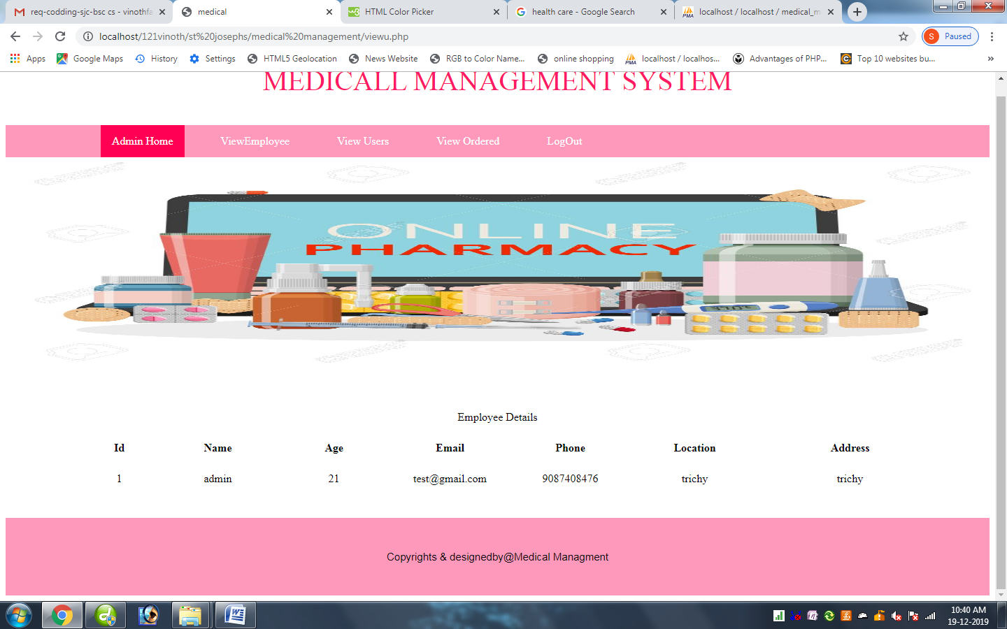

<?php

include("dbconnect.php");

extract($_POST);

session_start();

?>

<html>

<title> medical</title>

<style>

p

{

color:#ff1a66;

text-align: center;

text-transform: uppercase;

font-size:40px;

}

ul {

list-style-type: none;

margin: 0;

padding: 0;

overflow: hidden;

background-color: #ff99bb;

position: -webkit-sticky; /* Safari */

position: sticky;

top: 0;

border-radius:0px;

}

li {

float: left;

}

li a {

display: block;

color: white;

text-align: center;

padding: 14px 16px;

text-decoration: none;

}

li a:hover {

background-color: #ff0055;

}

.active {

background-color: #ff0055;

}

#footer {

border: 2px solid #ff99bb;

padding: 45px;

background: #ff99bb;

background-repeat: no-repeat;

background-size: 1420px 100px;

border-radius:0px;

text-align:center;

text-decoration:blink;

font-family: Arial;

font-size:15px;

}

#bg1 {

padding:180px;

background:url("images/1.jpg");

background-repeat: no-repeat;

background-size: 1420px 300px;

border-radius:5px;

border-radius:0px;

font-size:35px;

}

</style>

</head>

<p>Medicall Management System</p>

<ul>

<li><a href="#">&nbsp; &nbsp; &nbsp; &nbsp; &nbsp;</a></li>

<li><a href="#">&nbsp; &nbsp; &nbsp; &nbsp; &nbsp;</a></li>

<li><a class="active" href="adminhome.php">Admin Home</a></li>

<li><a href="#">&nbsp;</a></li>

<li><a href="viewe.php">ViewEmployee</a></li>

<li><a href="#">&nbsp;</a></li>

<li><a href="viewu.php">View Users</a></li>

<li><a href="#">&nbsp;</a></li>

<li><a href="viewo.php">View Ordered</a></li>

<li><a href="#">&nbsp;</a></li>

<li><a href="index.php">LogOut</a></li>

</ul>

<div id="bg1"> </div>

<table width="91%" align="center">

<tr>

<td colspan="10" align="center">Employee Details</td>

</tr>

<tr>

<td colspan="10">&nbsp;</td>

</tr>

<tr>

<td width="3%">&nbsp;</td>

<td width="9%"><div align="center" class="style6"><strong>Id</strong> </div></td>

<td width="13%"><div align="center" class="style6"><strong>Name</strong> </div></td>

<td width="13%"><div align="center" class="style6"><strong>Age</strong> </div></td>

<td width="13%"><div align="center" class="style6"><strong>Email</strong> </div></td>

<td width="14%"><div align="center" class="style6"><strong>Phone</strong> </div></td>

<td width="14%"><div align="center" class="style6"><strong>Location</strong> </div></td>

<td width="21%"><div align="center" class="style6"><strong>Address</strong> </div></td>

</tr>

<tr>

<td colspan="10">&nbsp;</td>

</tr>

<?php

$qry=mysql_query("select * from register");

$i=1;

while($row=mysql_fetch_array($qry))

{

?>

<tr>

<td width="3%">&nbsp;</td>

<td><div align="center"><?php echo $row['id'];?></div></td>

<td><div align="center"><?php echo $row['name'];?></div></td>

<td><div align="center"><?php echo $row['age'];?></div></td>

<td><div align="center"><?php echo $row['email'];?></div></td>

<td><div align="center"><?php echo $row['phone'];?></div></td>

<td><div align="center"><?php echo $row['location'];?></div></td>

<td><div align="center"><?php echo $row['address'];?></div></td>

</tr>

<tr>

<td>&nbsp;</td>

<td>&nbsp;</td>

<td>&nbsp;</td>

<td>&nbsp;</td>

<td>&nbsp;</td>

<td>&nbsp;</td>

<td width="14%">&nbsp;</td>

</tr>

<?php

$i++;

}

?>

<tr>

<td colspan="10" align="center">&nbsp;</td>

</tr>

</table>

<div id="footer"> Copyrights & designedby@Medical Managment</div>

Viewo.php

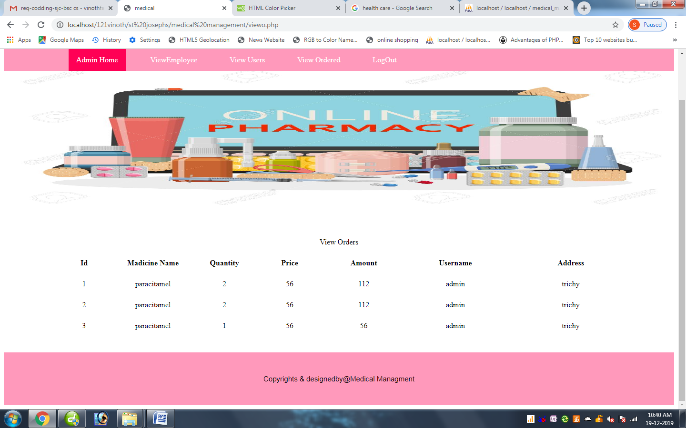

<?php

include("dbconnect.php");

extract($_POST);

session_start();

?>

<html>

<title> medical</title>

<style>

p

{

color:#ff1a66;

text-align: center;

text-transform: uppercase;

font-size:40px;

}

ul {

list-style-type: none;

margin: 0;

padding: 0;

overflow: hidden;

background-color: #ff99bb;

position: -webkit-sticky; /* Safari */

position: sticky;

top: 0;

border-radius:0px;

}

li {

float: left;

}

li a {

display: block;

color: white;

text-align: center;

padding: 14px 16px;

text-decoration: none;

}

li a:hover {

background-color: #ff0055;

}

.active {

background-color: #ff0055;

}

#footer {

border: 2px solid #ff99bb;

padding: 45px;

background: #ff99bb;

background-repeat: no-repeat;

background-size: 1420px 100px;

border-radius:0px;

text-align:center;

text-decoration:blink;

font-family: Arial;

font-size:15px;

}

#bg1 {

padding:180px;

background:url("images/1.jpg");

background-repeat: no-repeat;

background-size: 1420px 300px;

border-radius:5px;

border-radius:0px;

font-size:35px;

}

</style>

</head>

<p>Medicall Management System</p>

<ul>

<li><a href="#">&nbsp; &nbsp; &nbsp; &nbsp; &nbsp;</a></li>

<li><a href="#">&nbsp; &nbsp; &nbsp; &nbsp; &nbsp;</a></li>

<li><a class="active" href="adminhome.php">Admin Home</a></li>

<li><a href="#">&nbsp;</a></li>

<li><a href="viewe.php">ViewEmployee</a></li>

<li><a href="#">&nbsp;</a></li>

<li><a href="viewu.php">View Users</a></li>

<li><a href="#">&nbsp;</a></li>

<li><a href="viewo.php">View Ordered</a></li>

<li><a href="#">&nbsp;</a></li>

<li><a href="index.php">LogOut</a></li>

</ul>

<div id="bg1"> </div>

<table width="89%" align="center">

<tr>

<td colspan="10" align="center">View Orders</td>

</tr>

<tr>

<td colspan="10">&nbsp;</td>

</tr>

<tr>

<td width="2%">&nbsp;</td>

<td width="10%"><div align="center" class="style6"><strong>Id</strong> </div></td>

<td width="13%"><div align="center" class="style6"><strong>Madicine Name</strong> </div></td>

<td width="11%"><div align="center" class="style6"><strong>Quantity</strong> </div></td>

<td width="11%"><div align="center" class="style6"><strong>Price</strong> </div></td>

<td width="14%"><div align="center" class="style6"><strong>Amount</strong> </div></td>

<td width="17%"><div align="center" class="style6"><strong>Username</strong> </div></td>

<td width="22%"><div align="center" class="style6"><strong>Address</strong> </div></td>

</tr>

<tr>

<td colspan="10">&nbsp;</td>

</tr>

<?php

$qry=mysql_query("select * from addcart where status='1'");

$i=1;

while($row=mysql_fetch_array($qry))

{

$pid=$row['bid'];

$uid=$row['uid'];

$qry1=mysql_query("select * from product where id='$pid'");

$row1=mysql_fetch_array($qry1);

$qry2=mysql_query("select * from register where id='$uid'");

$row2=mysql_fetch_array($qry2);

?>

<tr>

<td width="2%">&nbsp;</td>

<td><div align="center"><?php echo $row['id'];?></div></td>

<td><div align="center"><?php echo $row1['name'];?></div></td>

<td><div align="center"><?php echo $row['quantity'];?></div></td>

<td><div align="center"><?php echo $row['price'];?></div></td>

<td><div align="center"><?php echo $row['amount'];?></div></td>

<td><div align="center"><?php echo $row2['name'];?></div></td>

<td><div align="center"><?php echo $row2['address'];?></div></td>

</tr>

<tr>

<td>&nbsp;</td>

<td>&nbsp;</td>

<td>&nbsp;</td>

<td>&nbsp;</td>

<td>&nbsp;</td>

<td>&nbsp;</td>

<td width="17%">&nbsp;</td>

</tr>

<?php

$i++;

}

?>

<tr>

<td colspan="10" align="center">&nbsp;</td>

</tr>

</table>

<div id="footer"> Copyrights & designedby@Medical Managment</div>

Emphome.php

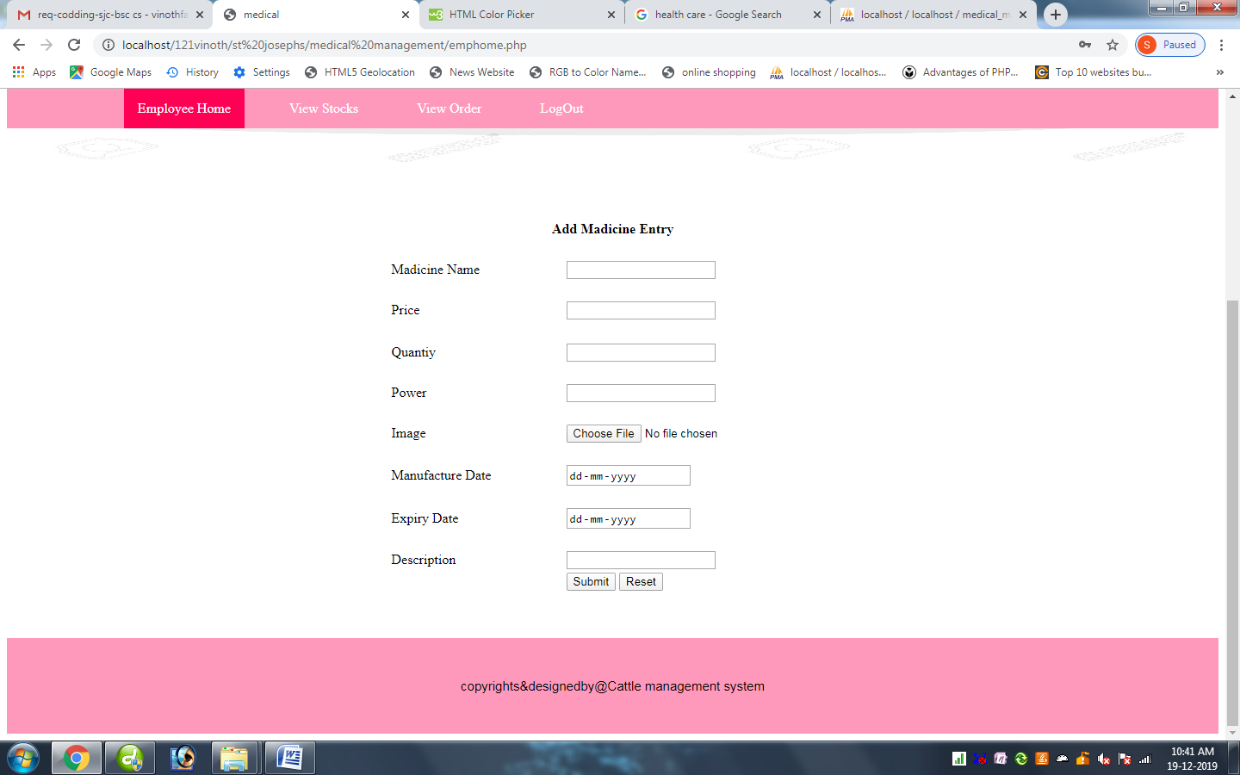

Views.php

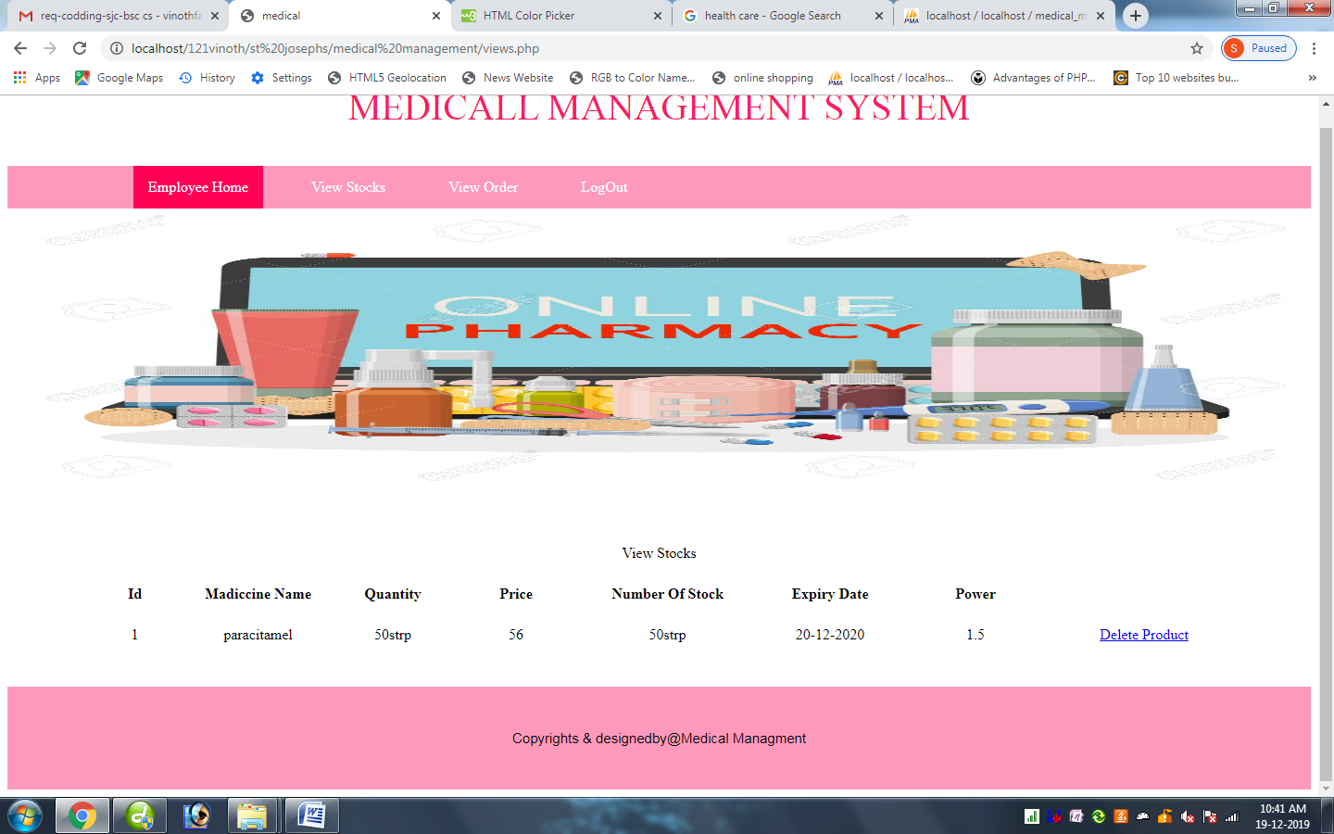

<?php

include("dbconnect.php");

extract($_POST);

session_start();

?>

<html>

<title> medical</title>

<style>

p

{

color:#ff1a66;

text-align: center;

text-transform: uppercase;

font-size:40px;

}

ul {

list-style-type: none;

margin: 0;

padding: 0;

overflow: hidden;

background-color: #ff99bb;

position: -webkit-sticky; /* Safari */

position: sticky;

top: 0;

border-radius:0px;

}

li {

float: left;

}

li a {

display: block;

color: white;

text-align: center;

padding: 14px 16px;

text-decoration: none;

}

li a:hover {

background-color: #ff0055;

}

.active {

background-color: #ff0055;

}

#footer {

border: 2px solid #ff99bb;

padding: 45px;

background: #ff99bb;

background-repeat: no-repeat;

background-size: 1420px 100px;

border-radius:0px;

text-align:center;

text-decoration:blink;

font-family: Arial;

font-size:15px;

}

#bg1 {

padding:180px;

background:url("images/1.jpg");

background-repeat: no-repeat;

background-size: 1420px 300px;

border-radius:5px;

border-radius:0px;

font-size:35px;

}

</style>

</head>

<p>Medicall Management System</p>

<ul>

<li><a href="#">&nbsp; &nbsp; &nbsp; &nbsp; &nbsp;</a></li>

<li><a href="#">&nbsp; &nbsp; &nbsp; &nbsp; &nbsp;</a></li>

<li><a class="active" href="emphome.php">Employee Home</a></li>

<li><a href="#">&nbsp;</a></li>

<li><a href="views.php">View Stocks</a></li>

<li><a href="#">&nbsp;</a></li>

<li><a href="orders.php">View Order</a></li>

<li><a href="#">&nbsp;</a></li>

<li><a href="index.php">LogOut</a></li>

</ul>

<div id="bg1"> </div>

<table width="90%" align="center">

<tr>

<td colspan="10" align="center">View Stocks</td>

</tr>

<tr>

<td colspan="10">&nbsp;</td>

</tr>

<tr>

<td width="1%">&nbsp;</td>

<td width="8%"><div align="center" class="style6"><strong>Id</strong> </div></td>

<td width="13%"><div align="center" class="style6"><strong>Madiccine Name</strong> </div></td>

<td width="10%"><div align="center" class="style6"><strong>Quantity</strong> </div></td>

<td width="11%"><div align="center" class="style6"><strong>Price</strong> </div></td>

<td width="15%"><div align="center" class="style6"><strong>Number Of Stock</strong> </div></td>

<td width="13%"><div align="center" class="style6"><strong>Expiry Date</strong> </div></td>

<td width="12%"><div align="center" class="style6"><strong>Power</strong> </div></td>

</tr>

<tr>

<td colspan="10">&nbsp;</td>

</tr>

<?php

$qry=mysql_query("select * from product");

$i=1;

while($row=mysql_fetch_array($qry))

{

?>

<tr>

<td width="1%">&nbsp;</td>

<td><div align="center"><?php echo $row['id'];?></div></td>

<td><div align="center"><?php echo $row['name'];?></div></td>

<td><div align="center"><?php echo $row['qty'];?></div></td>

<td><div align="center"><?php echo $row['price'];?></div></td>

<td><div align="center"><?php echo $row['qty'];?></div></td>

<td><div align="center"><?php echo $row['exd'];?></div></td>

<td><div align="center"><?php echo $row['power'];?></div></td>

<td width="17%"><div align="center"><a href="views.php?act=del&id=<?php echo $row['id'];?>">Delete Product</a></div></td>

</tr>

<tr>

<td>&nbsp;</td>

<td>&nbsp;</td>

<td>&nbsp;</td>

<td>&nbsp;</td>

<td>&nbsp;</td>

<td>&nbsp;</td>

<td width="13%">&nbsp;</td>

</tr>

<?php

$i++;

}

if($_REQUEST["act"]==('del'))

{

$did=$_REQUEST['id'];

$qt=mysql_query("delete from product where id='$did'");

echo "deleted Sucessfully";

}

?>

<tr>

<td colspan="10" align="center">&nbsp;</td>

</tr>

</table>

<div id="footer"> Copyrights & designedby@Medical Managment</div>

Orders.php

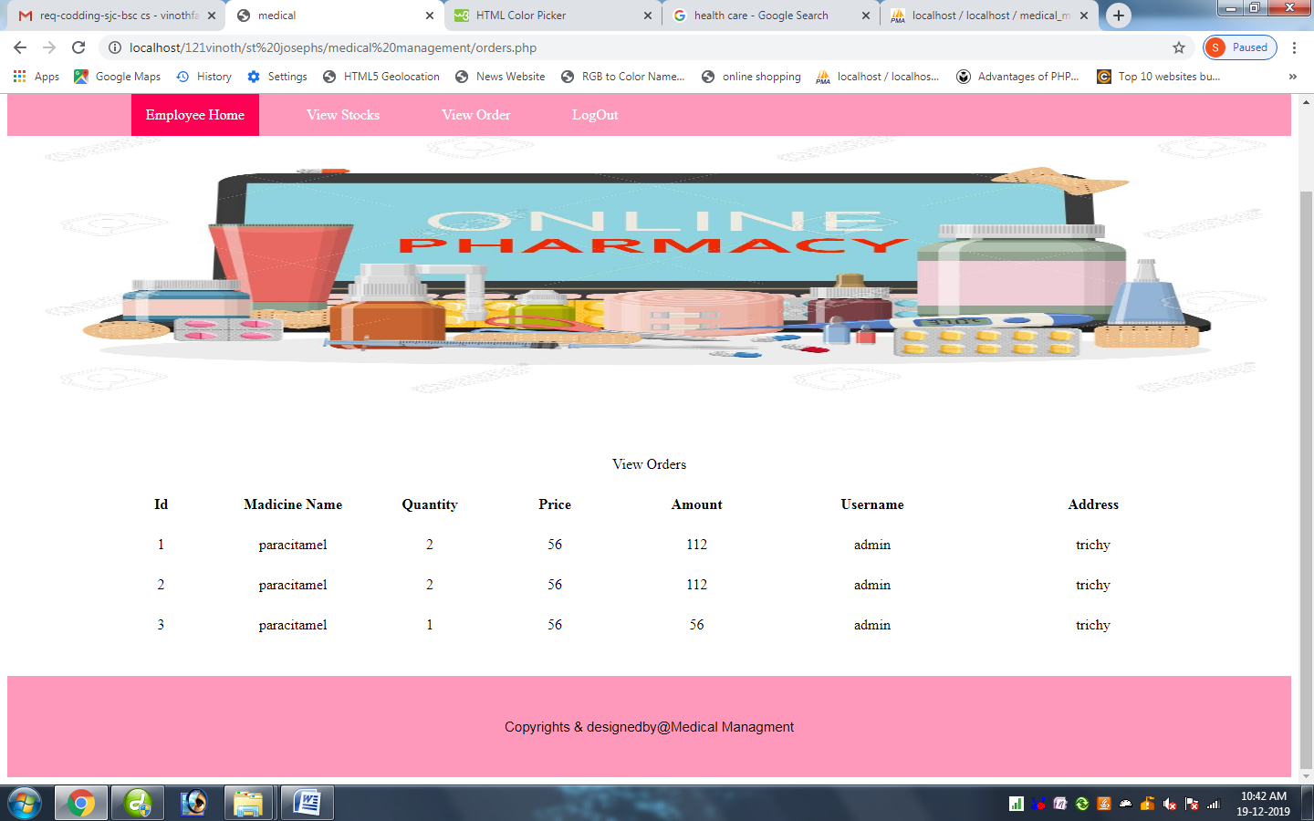

<?php

include("dbconnect.php");

extract($_POST);

session_start();

?>

<html>

<title> medical</title>

<style>

p

{

color:#ff1a66;

text-align: center;

text-transform: uppercase;

font-size:40px;

}

ul {

list-style-type: none;

margin: 0;

padding: 0;

overflow: hidden;

background-color: #ff99bb;

position: -webkit-sticky; /* Safari */

position: sticky;

top: 0;

border-radius:0px;

}

li {

float: left;

}

li a {

display: block;

color: white;

text-align: center;

padding: 14px 16px;

text-decoration: none;

}

li a:hover {

background-color: #ff0055;

}

.active {

background-color: #ff0055;

}

#footer {

border: 2px solid #ff99bb;

padding: 45px;

background: #ff99bb;

background-repeat: no-repeat;

background-size: 1420px 100px;

border-radius:0px;

text-align:center;

text-decoration:blink;

font-family: Arial;

font-size:15px;

}

#bg1 {

padding:180px;

background:url("images/1.jpg");

background-repeat: no-repeat;

background-size: 1420px 300px;

border-radius:5px;

border-radius:0px;

font-size:35px;

}

</style>

</head>

<p>Medicall Management System</p>

<ul>

<li><a href="#">&nbsp; &nbsp; &nbsp; &nbsp; &nbsp;</a></li>

<li><a href="#">&nbsp; &nbsp; &nbsp; &nbsp; &nbsp;</a></li>

<li><a class="active" href="emphome.php">Employee Home</a></li>

<li><a href="#">&nbsp;</a></li>

<li><a href="views.php">View Stocks</a></li>

<li><a href="#">&nbsp;</a></li>

<li><a href="orders.php">View Order</a></li>

<li><a href="#">&nbsp;</a></li>

<li><a href="index.php">LogOut</a></li>

</ul>

<div id="bg1"> </div>

<table width="89%" align="center">

<tr>

<td colspan="10" align="center">View Orders</td>

</tr>

<tr>

<td colspan="10">&nbsp;</td>

</tr>

<tr>

<td width="2%">&nbsp;</td>

<td width="10%"><div align="center" class="style6"><strong>Id</strong> </div></td>

<td width="13%"><div align="center" class="style6"><strong>Madicine Name</strong> </div></td>

<td width="11%"><div align="center" class="style6"><strong>Quantity</strong> </div></td>

<td width="11%"><div align="center" class="style6"><strong>Price</strong> </div></td>

<td width="14%"><div align="center" class="style6"><strong>Amount</strong> </div></td>

<td width="17%"><div align="center" class="style6"><strong>Username</strong> </div></td>

<td width="22%"><div align="center" class="style6"><strong>Address</strong> </div></td>

</tr>

<tr>

<td colspan="10">&nbsp;</td>

</tr>

<?php

$qry=mysql_query("select * from addcart where status='1'");

$i=1;

while($row=mysql_fetch_array($qry))

{

$pid=$row['bid'];

$uid=$row['uid'];

$qry1=mysql_query("select * from product where id='$pid'");

$row1=mysql_fetch_array($qry1);

$qry2=mysql_query("select * from register where id='$uid'");

$row2=mysql_fetch_array($qry2);

?>

<tr>

<td width="2%">&nbsp;</td>

<td><div align="center"><?php echo $row['id'];?></div></td>

<td><div align="center"><?php echo $row1['name'];?></div></td>

<td><div align="center"><?php echo $row['quantity'];?></div></td>

<td><div align="center"><?php echo $row['price'];?></div></td>

<td><div align="center"><?php echo $row['amount'];?></div></td>

<td><div align="center"><?php echo $row2['name'];?></div></td>

<td><div align="center"><?php echo $row2['address'];?></div></td>

</tr>

<tr>

<td>&nbsp;</td>

<td>&nbsp;</td>

<td>&nbsp;</td>

<td>&nbsp;</td>

<td>&nbsp;</td>

<td>&nbsp;</td>

<td width="17%">&nbsp;</td>

</tr>

<?php

$i++;

}

?>

<tr>

<td colspan="10" align="center">&nbsp;</td>

</tr>

</table>

<div id="footer"> Copyrights & designedby@Medical Managment</div>